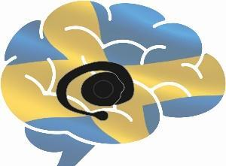
Annual report from the board of SWEBAGS

This year started with keynote lectures by the newly elected honorary members Ann Graybiel and Hagai Bergman.
For the year of 2022 the number of members has increased and we have gained 116 new members reaching up to a total of 283 members from 101 different organisations in 22 countries.

During 2022 the following persons constituted the board:
- Jeanette Hellgren Kotaleski - EBRAINS contact and Chair
- Angela Cenci Nilsson - Translational research representative, Vice chair
- Arvind Kumar - Computational science and machine learning research representative, Education representative
- Daniel Vare – Secretary
- Gilad Silberberg - Neurophysiology research representative, Education representative
- Gilberto Fisone - IBAGS relationship representative
- Gesine Paul-Visse - Swemodis representative

Per Peterson - Behavioural and system neuroscience representative

Peder Svensson - SME relationship representative

Åsa Mackenzie - Affective and associative functions representative

Peder Svensson – substitute SME relationship representative
Activities
The monthly webinars has continues being a very popular event with a good turnout also this year. We have this year arranged 9 public webinars and have one scheduled conference for November 30 with more than 150 registered participants.

A big thanks for this year to all new and old members!
Jeanette Hellgren Kotaleski
Chair

